***PAAREES PERFUMES***

***DAVIDOFF***

***FOR MEN***

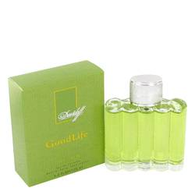

***Good Life***

***Description:***

Good Life by Davidoff Cologne. Share the pleasures of life by spritzing a few drops of Good Life by Davidoff on yourself before starting your day. Bursting with a rich fragrant aromas of grass, wood and fruits, this men's fragrance is bound to keep you smelling fresh and clean all day long. Notes of fig leaf and tea add a fresh earthy twist to this invigorating scent, while an explosion of bergamot and melon provides a citrusy fruity aroma. The spicy essence of black currant ends this fragrance with a bang.